|  |
| --- |
| Antravi Destinations Contact Start planning now  Blue Back ground or white which ever suits better as per below image  Green highlighted text should be in white or black |

**Background video related to the Maldives vibe / refer below image for reference**

**ANTRAVI**

**Live Your Moments.**

Start planning now – Lead form

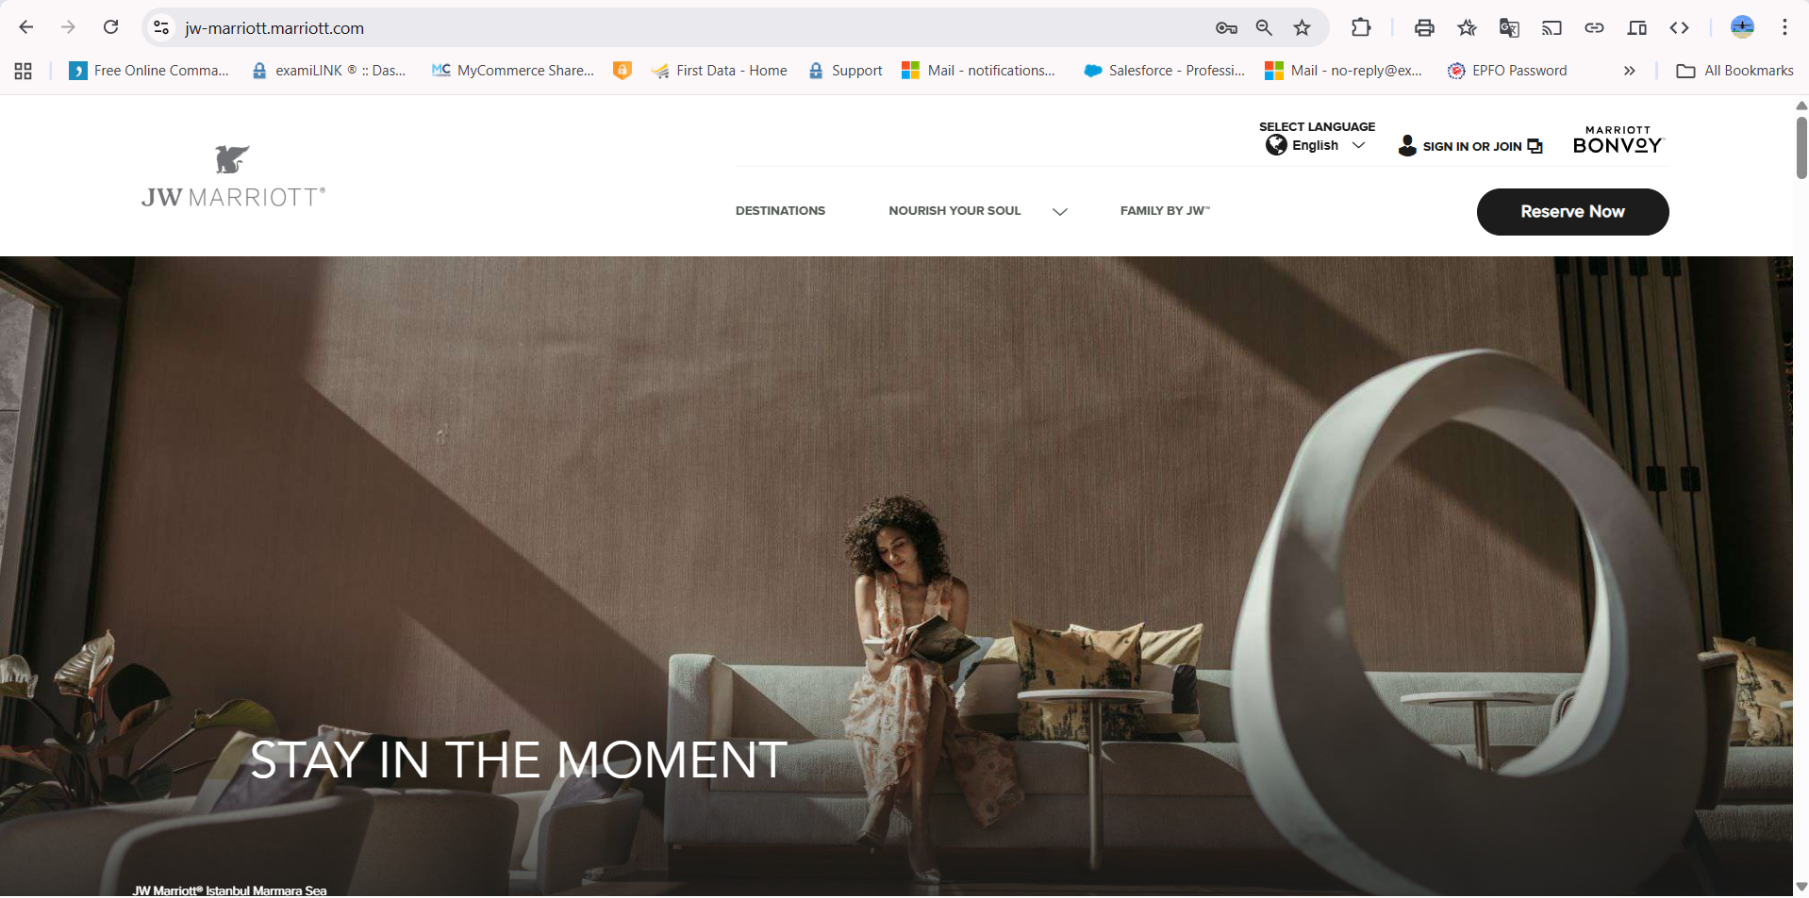

|  |
| --- |
| **Your Vacation, by Antravi**  A vacation is where comfort meets care. Whether it’s a honeymoon, a family getaway, or a luxury retreat — every moment with Antravi is curated just for you. Choose Antravi to let your vacation feel as special as it truly is.  Background colour should be in simple white or grey refer : [**jw-marriott.com**](https://jw-marriott.marriott.com/) **for reference**  **Start planning now** - (when someone clicks , form needs to come)  Space left for reviews  Rating with stars – needs to be filled with yellow as per ratings    Our Featured Destinations  **The Maldives**    **Live your Moments**  Travel is more than just reaching a destination — it’s about savouring the little moments that stay with you forever.  At Antravi, we craft vacations that awaken your senses: the sight of turquoise waters, the soothing sound of gentle waves, and the joy of unhurried time spent with those you love. Every detail is thoughtfully curated to truly experience the world in its most beautiful, heartfelt form.  **Plan Your Maldives Trip in 3 Simple Steps**   1. **Tell us what you need —** It’s your trip, your way. We begin with a conversation to understand what matters to you. 2. **We curate options —** Resorts, transfers, experiences— we tailor everything around your preferences. 3. **Confirm and travel —** When you’re ready, we’ll be there — to guide and support you, so you can focus on what matters most: Live your Moments.   Start Planning with Antravi - (when someone clicks , form needs to come)  Need to delete this page |
| Antravi's handful of collections  **Resort Name 01**  **Rating:** 4.8 / 5 **Villa Types:** Overwater Villa, Beach Suite, Family Villa **Stay Duration:** 4 Nights/5Days  **Includes:** Accommodation, Transfer, Resort Taxes, 24/7 At your service  **From :** ₹1.2L–1.5L per couple (excl. flights) ,  **[ Plan My vacation ] — (click opens enquiry form)**  **Resort Name 02**  **Rating:** 4.8 / 5 **Available Room Types:** Overwater Villa, Beach Suite, Family Villa **Stay Duration:** 4 Nights **Includes:** Accommodation, Transfer, Resort Taxes, 24/7 At your service  **From :** ₹1.2L–1.5L per couple (excl. flights) ,  **[ Plan My vacation ] — (click opens enquiry form)**  **Resort Name 03**  **Rating:** 4.8 / 5 **Available Room Types:** Overwater Villa, Beach Suite, Family Villa **Stay Duration:** 4 Nights **Includes:** Accommodation, Transfer, Resort Taxes, 24/7 At your service  **From :** ₹1.2L–1.5L per couple (excl. flights) ,  **[ Plan My vacation ] — (click opens enquiry form)**  Instagram posts slide show showcasing clients feedback/ resort highlights  Lets us craft your Maldives vacation – beautiful and personal  Start Planning with Antravi 🡪 This should be clickable , when someone clicks form should open  FAQ’s will share  Antravi ---Written in Black with whit background  Live your Moments. -- Written in Black with whit background  Background colour should be blue Footer    Social icons --- Written in white  Contact no  Email      Office address -- Written in white | | |

**Suggested Fields (With Purpose):**

1. **Full Name**  
   *(Basic need, adds a personal touch)*
2. **Email Address**  
   *(Required for follow-up; use validation to block fake ones)*
3. **Phone Number** *(Optional but preferred)*  
   *(Reduces junk; serious clients will share it)*
4. **Preferred Travel Dates**  
   *(Helps with pricing clarity + filters non-serious users)*
5. **Occasion**

* Honeymoon
* Family Vacation
* Luxury Break
* Other (with short box)

✅ Helps personalize the offer  
✅ Also reveals intent (real traveler vs random)

1. **Preferred Budget Range** *(optional dropdown)*

* Below ₹1L
* ₹1L–₹1.5L
* ₹1.5L–₹2L
* ₹2L+  
  *(This will pre-qualify leads and avoid mismatch)*

1. **Additional Requests / Notes** *(Short text box)*  
   *“We craft each trip personally. Please share as much detail as you're comfortable with — it helps us serve you better.”*

**⚠️ Anti-Junk Add-ons (Subtle, Non-blocking):**

* **Human check question: “To keep our service personal and spam-free, please solve this question.**  
  *“What’s (e.g., 14 × 3) ?”* or *“Type the name of the destination you want to visit.”*  
  (Filters bots + unserious users.)

**📝 Add This Line Below the Form or Near the Submit Button:**

💬 *Note:* ***Final pricing may vary based on your travel dates and availability.*** *We’ll share the best available options tailored for you.*

This sets the right pricing expectation without feeling like a warning.

Start my Maldives Journey – this will be the button

**You said:**

Boom! Your vacation plan request is in — time to start dreaming about turquoise waters and sunny skies ☀️🌴 We’ll be in touch soon with your getaway details! - Get ready to live your moments!

Boom! Your vacation request just landed in our inbox — it’s time to start dreaming of oceanfront serenity and golden sunsets as we begin crafting your getaway. Get ready to live your moments!

FAQ;S

**1. Which is the best time to visit the Maldives?**

The Maldives is beautiful year-round, but the best time to visit is **between November and April**, when the skies are clear and the seas are calm — perfect for honeymoons and beachside moments. That said, we also help travelers plan magical escapes in the off-season, where you can enjoy **fewer crowds and better resort value**.

**🛬 2. Do Indians need a visa for the Maldives?**

No visa hassles here! Indian passport holders receive a **free Visa on Arrival** for up to 30 days. All you need is a passport valid for at least 6 months, a confirmed return flight, and your hotel booking — which we’ll provide you after confirmation. We’ll guide you through everything.

**💸 3. What’s included in Antravi’s Maldives packages?**

Every Antravi itinerary is crafted around you — but typical inclusions are:

* Resort accommodation
* Airport transfers (speedboat or seaplane)
* All meals or selected meal plans
* Taxes, green fees & travel concierge support  
  Need something special like a candlelit dinner or overwater spa? Just say the word.

**💳 4. Which currency should I carry in the Maldives?**

While the official currency is **Maldivian Rufiyaa (MVR)**, most resorts prefer **US Dollars (USD)** for payments. We recommend carrying a mix of USD cash and an international card. No need to exchange currency in advance — we’ll guide you based on your resort.

**🍽️ 5. Are meals included in the packages?**

Yes — and we help you choose the right meal plan. From **bed & breakfast** to **all-inclusive**, we tailor it based on your travel style and budget. Honeymooners often prefer all-inclusive for ease, while families might enjoy flexible dining options.

**🌊 6. Is alcohol allowed in the Maldives?**

Yes — **alcohol is available at all private island resorts**. However, it’s restricted on local islands due to cultural laws. But don't worry — most of our curated resorts include beautiful bars, beach cocktails, and even floating champagne breakfasts!

**🐠 7. What should I pack for the Maldives?**

Keep it light and breezy. Think:

* Swimsuits, breathable clothing, sun hats
* Reef-safe sunscreen, sunglasses
* Optional: GoPro, waterproof pouch, light flip flops  
  We’ll also send you a **personalized packing guide** before your trip — because we love the little details too.

**🧳 8. Can I customize my Maldives package with Antravi?**

Absolutely — that’s what we’re known for. Whether it’s a **romantic split-stay**, a **private pool villa**, or **family-friendly excursions**, your Maldives holiday is designed around your story. We listen first, then build a vacation you’ll never forget.